**Needs Assessment Survey**

*This document outlines the details of the survey.*

The email and landing page of the survey describe the survey to the otologists who will be asked to fill it out. Implied consent is requested so the survey results remain anonymous. The figure below is an example of an invitation to participate in a survey sent to the PI. The language used is a guide used to describe our survey.

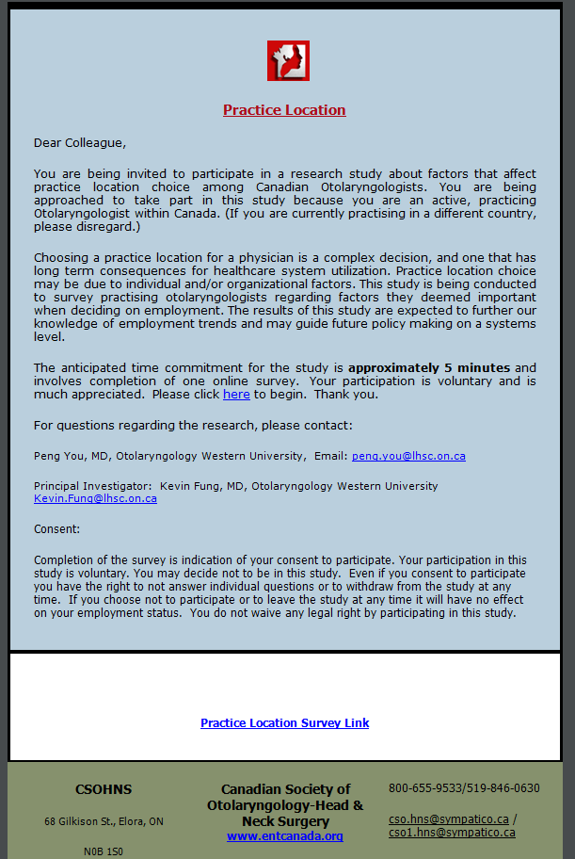

**Email Invitation:**

The email invitation will contain the following email script:

“Dear Colleague,

**Endoscopic ear surgery instruments**

You are invited to participate in a research study evaluating the suitability of surgical instruments for endoscopic ear surgery. We would appreciate your responses if you currently perform any ear surgery, whether you use endoscopes or not.

<Link to survey>

The survey contains ten simple questions and takes approximately **5 mins** to complete**.** Your identity will not be recorded and participation will not affect your professional status or integrity in any way.. This study will be conducted using the Delphi method: responses of this survey may be used to generate a second survey with more specific questions. The results of this needs analysis will be used to stimulate the design of new instruments optimized for endoscopic ear surgery.

For questions regarding the research, please contact:

Arushri Swarup, MASc. Candidate, Institute for Biomaterials and Biomedical Engineering, University of Toronto, email: arushri.swarup@sickkids.ca

Principal Investigator: Dr. Adrian James, Associate Professor, Department of Otolaryngology Head & Neck Surgery, University of Toronto, email: adrian.james@sickkids.ca

Consent:

By completing and submitting the survey, it will be implied that you consent to participating in the study. Your participation in this study is voluntary, anonymous and confidential. You may decide not to be in this study. Even if you consent to participate you have the right to not answer individual questions or to withdraw from the study at any time.

The survey is available by clicking on the link below:

<Link to survey>”

**Landing Page of Survey:**

Before starting the survey, the following will describe the study.

“There is growing interest amongst otologists worldwide around the use of endoscopes in ear surgery. As most ear surgery instruments were developed for use with the microscope, it is possible that changes in instrument design for use with endoscopes may allow more procedures to be completed effectively with a totally endoscopic approach. This project is a not for profit initiative to stimulate the development of instrumentation optimized for endoscopic ear surgery. This survey aims to investigate the suitability of currently available instruments for use in endoscopic ear surgery and identify priorities for improvements in instrument design.

The approximate time to complete the survey is **5 minutes**. The survey will be conducted via a two-round Delphi method. Responses to this survey will be collated and may be used to generate a second survey with more specific questions. The results will be summarised in an otolaryngological journal.

By completing and submitting the survey, it will be implied that you consent to participate. You may decide not to be in this study, and may withdraw at any time before submitting the survey. This survey is completely **voluntary** and will remain confidential and **anonymous** to the researchers. This survey is purely for research purposes.

We thank you for your time. Please continue to begin.”

**Questionnaire:**

Please refer to the Needs Assessment Questionnaire document.

**Follow Up Email Invitation:**

In the case that we do not receive any responses within two weeks, we will send out one follow-up email to the invited participants. The email will read:

“Dear Dr.__________,

This is a friendly follow up email to the request to participate in the voluntary survey, linked below, to gather information regarding the suitability of currently available instruments for use in endoscopic ear surgery

It is important to note that this survey is completely voluntary and will remain confidential and anonymous to the researchers. There will be no way to identify participants.. Participation or nonparticipation in this survey will not affect your professional integrity in any way. This survey is purely for research purposes.

By answering the questions in the survey and submitting it, it will be implied that you consent to filling out your survey and the researchers using the anonymous data to analyze and present it.

We thank you for your time. Please click below to begin.”

<Link to survey>